**Battle of Neighbourhoods - New York**

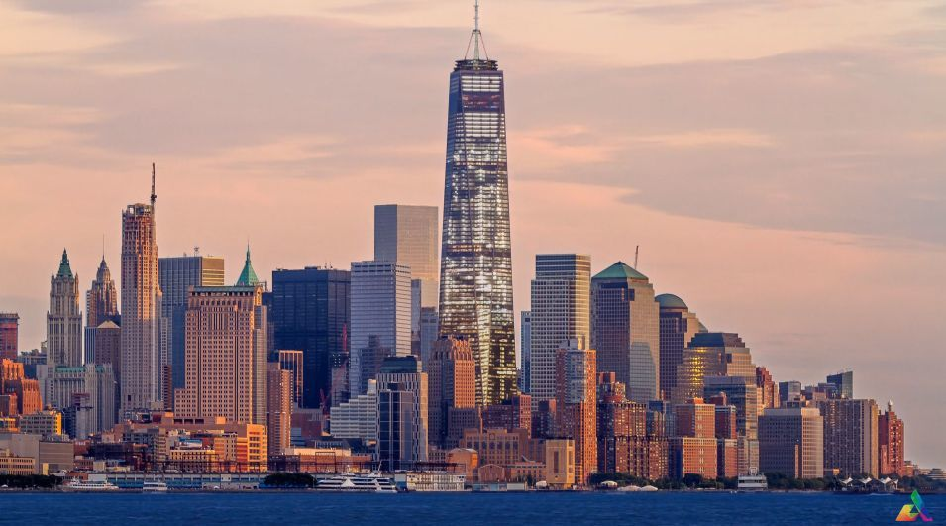

1. **Introduction & Business Problem:**

Objective of the final assignment of IBM Capstone Project were to define a real-life business problem, scrap data from the web and use Foursquare location data to compare different neighbourhood in New York to find out which neighbourhood is suitable for starting a restaurant business. In this report I will go through the Background and Business problem, data preparation and analysis section step by step.

**Background:** The city of New York is one of the world’s most populous megacities. It is most diversified as a lot of people from different countries live and work there. Being the most populous city in United states it provided with many business opportunities but it’s also very competitive. New York city has been described as the cultural, financial and media capital of the world. The analysis from this report will the new business strategically target the market.

**Problem:** The problem we are trying to solve here is to find a place in New York to open a new restaurant. Opening any type of business, you need to consider so many things for example Location, Niche, population around the location chosen and so on. There are few questions that we need answers for before moving forward.

1. What type of restaurant is going to be? Is it going to be fine dining restaurant or casual style dinner?

Ans - For this project we decide its going to be casual style dining restaurant.

1. What kind of food we are serving is it going to be specific cuisine that will be serving like French, Italian, Indian or Continental.

Ans – For this project we decide its going to be an Indian Restaurant.

In this analysis we will focus on Indian restaurants which are opened in and around the area and then decide if it’s a good place to open a new Indian restaurant based on the popularity of cuisine around that place and the competition.

**Target Audience:**

Targeted audience for this project will be an individual or company looking to open a new Indian restaurant business in New York City. The objective of this project will be to recommend a Borough/Neighbourhood is the best choice to start the Indian restaurant.

1. **Data**

For this project the city I will be analysing the neighbourhoods and Borough of New York City. We will be using different type of data from different sources.

**Source 1:** The source of New York city data is going to be <https://cocl.us/new_york_dataset>. From this source we can get the list of neighbourhoods and boroughs of New York city.

* The New York city has total of 5 Boroughs and 306 Neighbourhoods.

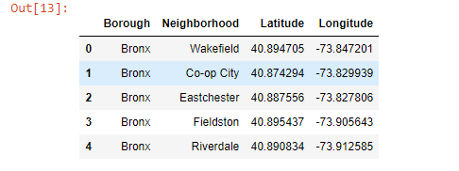

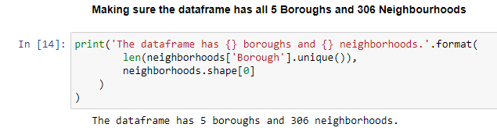

**Source 2:**  The co-ordinates that we got from for New York city will be passed in Foursquare API, that will give us the list of Indian restaurants for each neighbourhood. We will then use that information in further analysing the data.

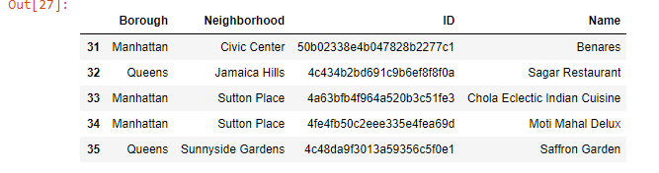

**Source 3 :**  To analyse the population of New York City scrapped the data from Wikipedia page <https://en.wikipedia.org/wiki/Demographics_of_New_York_City>. I used the pandas to scrap the data from the Wikipedia page.

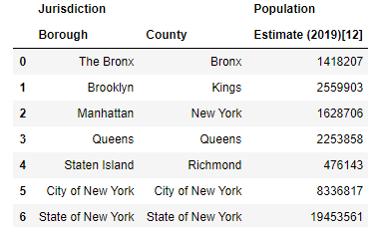

**Interests:**

The main interest of the business to be started as an Indian cuisine restaurant would be to know about criteria that can play avital role in making the business a success.

* Area which lack Indian restaurant
* Area which has Indian restaurant, but the ratings are low, opening a good and well managed restaurant can give the business an upper hand.
* Areas with potential Indian Restaurants.

**Methodology:**

The methodology used in this project is

**Data Gathering:** First acquiring all the necessary data needed to perform analysis. Once we acquired the data then we cleaned and transformed the data so that we can make some sense out of those numbers. To that we used visualisations so that we can understand the data better.

**Data Analysis:**

1. **Analysis of Neighbourhood & Boroughs data**

We started with looking at the Boroughs in New York City, to get an idea of distribution of Neighbourhoods among the Boroughs.

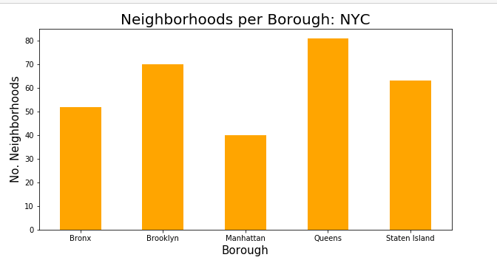

As you can see here Manhattan has the lowest number of Borough and Queens has the highest number of Borough followed by Brooklyn , Staten Island and Bronx.

1. **Analysis of Indian Restaurants data from Foursquare API**

Next we looked at the number of Indian Cuisine Restaurants in each Borough of New York City.

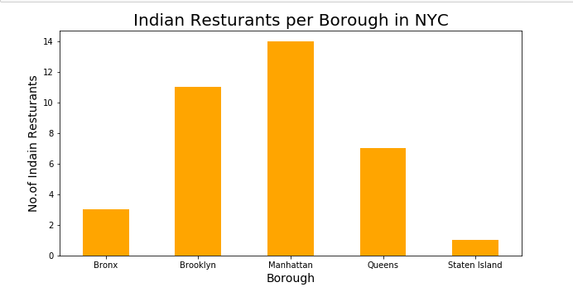

From this we saw the that Manhattan has the highest number of Indian restaurants followed by Brooklyn. From comparing the two charts above we can already start to see some potential for a good location for an Indian Restaurant. From the above graph I can see the Staten Island, Bronx and Queens will be ideal location to open a Indian cuisine restaurant as compare to Brooklyn and Manhattan.

1. **Analysis of Ratings data from Four Square API**

Now we look at the ratings of Indian restaurants in 5 boroughs of New York City.

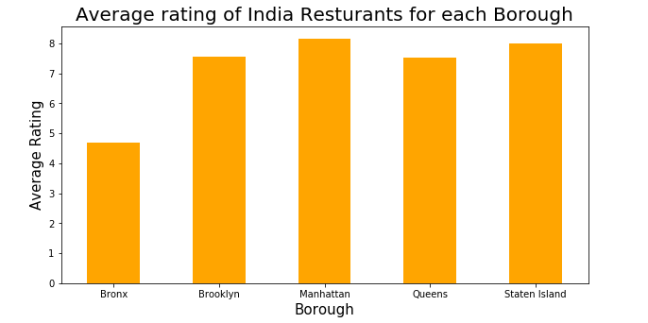

As we can see that rating of Indian restaurants in Manhattan and Staten Island are above 8 which is better than the other boroughs. So lets set look at the restaurants with average rating above 8.

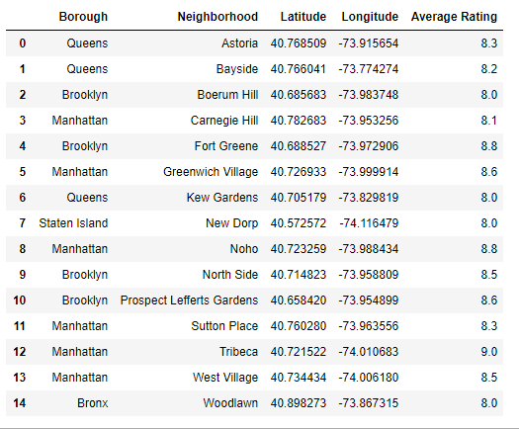

1. **Analysis of the population data.**

* Manhattan is the geographically smallest and most densely populated borough.
* Brooklyn on the western tip of long island is the city’s most populous borough.
* Queens on long island north and east of Brooklyn, is geographically the largest borough.

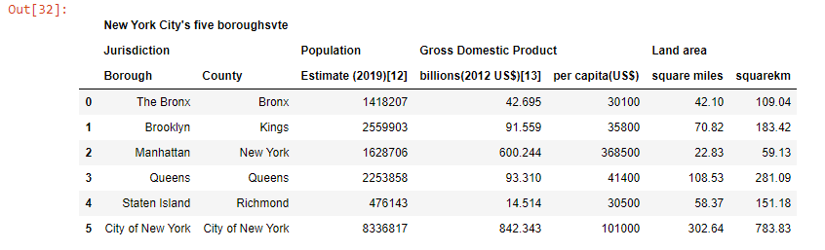

**Conclusion**

This analysis is performed on limited data. This may be right or may be wrong. But if good amount of data is available there is scope to come up with better results. If there are lot of restaurants probably there is a lot of demand. Brooklyn d Manhattan has high concentration of restaurant business. Very competitive market. Bronx, Queens and Staten island also has good number of restaurants but not as many as required. So we can explore this area.